## MACKINAC HORSEMEN’S ASSOCIATION MACKINAC COMMUNITY EQUESTRIAN CENTER

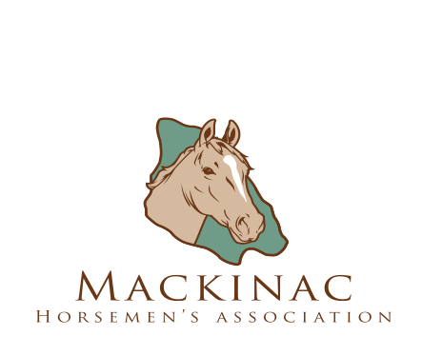

P.O. Box 462 • 3800 British Landing Road • Mackinac Island, MI 49757 906-847-8034 • [www.mackinachorses.org](http://www.mackinachorses.org/)

# *LIABLITY WAIVER AND RELEASE FORM*

I agree to the following as a condition of Mackinac Horsemen’s Association (“MHA”) allowing me, and the other person(s) identified below, to engage in one or more equine activities sponsored by MHA, including riding lessons, camps, boarding, horseback riding and the rental and use of tack and other equine equipment.

NAME OF CONTRACTING PARTY (Legal Adult) ISLAND ADDRESS: EMAIL: OFF-ISLAND ADDRESS:

ISLAND PHONE: (home) (work) (cell)

OFF-ISLAND PHONE: (home) (work) (cell)

I also make this agreement, waiver and release on behalf of the following who are my children or legal wards: Name Age: Name Age:

Name Age: Name Age:

* All parts of this agreement shall apply to me, as well as the children/legal wards listed above. (We will hereafter collectively call ourselves “I,” “me,” “we” or “my” throughout this agreement.) This agreement is binding from and after the date of its execution. Michigan law governs this agreement.
* We have the experience required to engage in the equine activities to which this Agreement relates. We have the following level of experience with horses, which MHA may rely upon:

**IT IS HEREBY AGREED AS FOLLOWS:**

1. I have requested to engage in certain equine activities sponsored by MHA and carried out on the property of MHA’s Mackinac Community Equestrian Center, in the City of Mackinac Island and the Mackinac Island State Park.
2. I understand that there is an inherent risk involved in horse related activities that anyone riding or near a horse can suffer bodily and other injuries. Horses are unpredictable by nature. Sounds, sudden movements or other distractions may cause a horse to behave in a way that could result in harm, injury or death to the participant. Horses are powerful and potentially dangerous. I understand these risks and dangers, and I voluntarily assume them. The social and economic losses that could result from the risks associated with equine activities could be severe. I am fully aware of and appreciate all of these risks associated with an equine activity. I understand that, despite the precautions taken, it is not possible to eliminate this risk.
3. I am fully responsible for my own safety while engaged in an equine activity. I have been advised that I am required to wear a safety helmet to reduce the severity of some head injuries while engaged in any equine activity sponsored by MHA or while on MHA property.
4. I acknowledge and agree that MHA and its officers, directors, and instructors are equine professionals as defined by the Michigan Equine Activity Liability Act (1994 P.A. 351), which provides in part:

## Under the Michigan Equine Activity Liability Act, an equine professional is not liable for an injury to or the death of a participant in an equine activity resulting from an inherent risk of the equine activity.

1. LIABILITY RELEASE and RELEASE: I assume full responsibility for any and all bodily injuries or damages which I may sustain when engaged in an equine activity pursuant to this Agreement. By the term "damages," I mean medical expenses, expenses incurred because of bodily injury or property damages, and/or personal property damages. I, for my heirs, administrators, personal representatives or assigns, release and discharge the owners and operators of MHA, the Mackinac Community Equestrian Center, the City of Mackinac Island, and the Mackinac Island State Park Commission, their owners, and their respective employees, agents, heirs, executors, administrators, representatives, successors and assigns of and from all claims, demands, actions, omissions, rights of action, or causes of action (present and future), liabilities, or obligations, whether the same be known or unknown, anticipated or unanticipated, resulting from or arising out of my or my guests' bodily injury or damage that may be sustained, or property damage. I also agree to indemnify and hold MHA, the Mackinac Community Equestrian Center, the City of Mackinac Island and the Mackinac Island State Park Commission, their owners, and their agents, employees and representatives harmless against all damages sustained by any third person(s) not parties to this Agreement, including, but not limited to, my relatives, guests, etc., including any and all claims, damages, or injuries whatsoever.
2. **I have read this agreement carefully, I understand it and I am signing it voluntarily**.

Name (party): Signature: Date:

## MACKINAC HORSEMEN’S ASSOCIATION MACKINAC COMMUNITY EQUESTRIAN CENTER

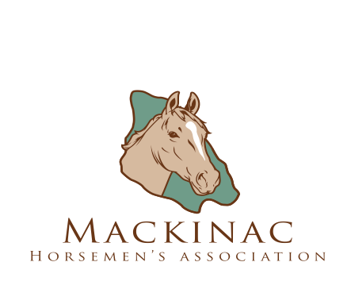

***PHOTO RELEASE FORM***

### Permission to Use Photograph

I grant Mackinac Horsemen’s Association, its representatives and employees the right to take photographs of me and my property in connection with the above-identified subject. I authorize Mackinac Horsemen’s Association, its assigns and transferees to copyright, use and publish the same in print and or electronically.

I agree that Mackinac Horsemen’s Association may use such photographs of me with or without my name and for any lawful purpose, including, for example, such purposes as publicity, illustration, advertising and web content.

I have read and understand the above.

Signature

Printed name

Organization name (if applicable)

Address

Date

Signature of parent or guardian (if under age 18)